Telegraph Journal April 8, 2015
Province needs tough payday loan regulations
RANDY HATFIELD COMMENTARY

New Brunswick is poised to become the eighth province to regulate payday lenders. It’s about time. Although legislation was passed in 2008 and 2014, it never has been proclaimed.

A regulatory framework needs to be put in place and the New Brunswick Financial and Consumer Services Commission has sought comments on proposed rules, including rates and fees. Payday loans (small unsecured loans made to a borrower who guarantees repayment in a short period of time — usually within 14 days) have a high cost of borrowing and have been characterized as leading to a debt cycle that has considerable impact on borrowers.

Payday loans are very expensive compared to other ways of borrowing money. They have become the most expensive short-term consumer loans on the market. They also tend to cater to low to moderate-income individuals who are unable to access traditional sources of credit.

The industry locates strategically within their target market – the working poor. This is borne out in New Brunswick’s major cities. Payday lenders in Saint John, Fredericton and Moncton cluster around low-income neighbourhoods.

This clustering is particularly evident in Saint John. The majority of payday lenders are located in Ward 3, where the overall poverty rate, according to 2012 tax filer data, was 31.1 percent. Nearly one in two children (47.9 percent) in Ward 3 lives in poverty. The ward also contains the highest percentage of renters of any of the city’s four wards at 66.5 percent.

The economic impact of payday lenders can be felt in neighbourhoods. When consumers pay payday loan interest and fees, they have less disposable income for rent, utilities, food and other local goods and services.

There are two features of the payday industry, in particular, that need to be addressed: the high cost of borrowing, and the debt cycle created by repeat and concurrent borrowing.

In the provinces where payday loans are regulated, their cost ranges from a low of $17 per $100 in Manitoba to a high of $25 per $100 in Prince Edward Island. (Last week, Nova Scotia’s Utility and Review Board recommended a drop in the maximum cost of borrowing from $25 to $22.) In the event of default there are further, substantial fees and charges.

The short-term nature of a payday loan belies the annual cost of borrowing.

The Annual Percentage Rate (APR) of the 14 day loan ranges from 443 percent in Manitoba to 651 percent in P.E.I.

Evidence before recent regulatory hearings suggests that payday lenders avoid price competition and charge the maximum allowable fees. Payday lenders are able to operate in Manitoba with a maximum total cost of credit of $17 and unless credible evidence is offered to prove that the industry could not survive in New Brunswick at this rate, the $17 rate should prevail.

The debt cycle caused by repeat borrowing and concurrent borrowing (where the lender has more than one loan at the same time) is well documented. Here’s how it works in the words of Linda Wilke, Atlantic Credit Counselling Services, when she made an appearance before the Nova Scotia Utility and Review Board on Feb. 10, 2015:

“You walk into a payday lender and borrow some money. You just essentially took an advance on your next pay cheque by way of a payday loan. What happens when you get paid? Well, you have to pay the loan back plus $25 per $100 borrowed. Let’s say you borrowed $400. You will repay $500. Now your next pay cheque is short $500. What do you do?
Can you live on that much less? What about rent? What about transportation? What about groceries, medications? Your solution? Get a repeat loan to replace the payment you made to the payday loan company, but this time you may have to borrow $500 to cover the costs. This continues until you reach the maximum amount you are permitted to borrow from that payday loan company. What’s next? You go to another payday lender, and now you are running current and repeat loans, a recipe for financial disaster.”

British Columbia deals with the issue by requiring a payday lender who makes three or more loans to a borrower in a 62 day period to allow borrowers to make repayment over at least three pay periods. On March 30, Nova Scotia’s Utility and Review Board recommended the adoption of British Columbia’s regulation. New Brunswick should follow suit.

The absence of provincial regulation has limited our understanding of the local industry – from the number of lenders to the size and number of loans. We are left to extrapolate data from other jurisdictions. A look at Nova Scotia is instructive:

More than 206,000 payday loans were issued in Nova Scotia between July 1, 2013 and June 30, 2014. The average loan was $433.

The payday loan business grew substantially in the three years ending on June 20, 2014. The estimated total value of loans granted grew from $77 million in 2011- 2012 to more than $89 million in 2013- 2014, an increase of approximately 15 percent.

Repeat loans accounted for 52 percent of the loans issued in 2013 – 2014.

Nova Scotia’s regulations contain detailed reporting requirements that should be adopted in this province.

Unless and until there are affordable and accessible credit products for the working poor there will be payday type lenders that offer high rate, short-term loans. New Brunswick has an obligation to regulate the industry on behalf of consumers. It also has an opportunity to take advantage of the experiences of other provinces.
Adopting the rate structure of Manitoba, the repeat borrowing repayment provisions of British Columbia and the data reporting requirements of Nova Scotia would make New Brunswick a leader in regulating the industry and protecting its consumers.

The province should also follow Manitoba’s lead and allocate a portion of the licensing fees collected from payday lenders to community-based financial literacy initiatives.

Finally, the province needs to amend its consumer legislation to mandate a triennial review of rules and regulations with specific provision for public and consumer representation.

New Brunswick, although late to regulate the industry, can – and should - be a leader in protecting its consumers.
RANDY HATFIELD is executive-director of the Saint John Human Development Council
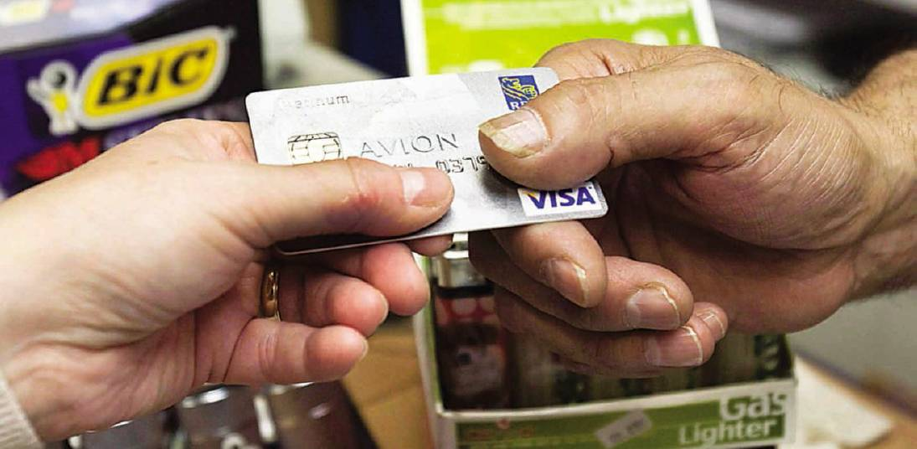
Canadians who are staggering under a hefty debt load may find turning to payday loan lenders as a last resort. Randy Hatfield of the Saint John Human Development Council says New Brunswick needs tough regulations to govern this growing financial lending industry. Photo: THE CANADIAN PRESS

