Energy poverty ‘needs serious attention’: community advocate

Human Development Council has provided the proof that vulnerable New Brunswickers suffer inordinately from high electricity prices
- Telegraph-Journal
- 13 Mar 2025
- JOHN CHILIBECK Local Journalism Initiative reporter
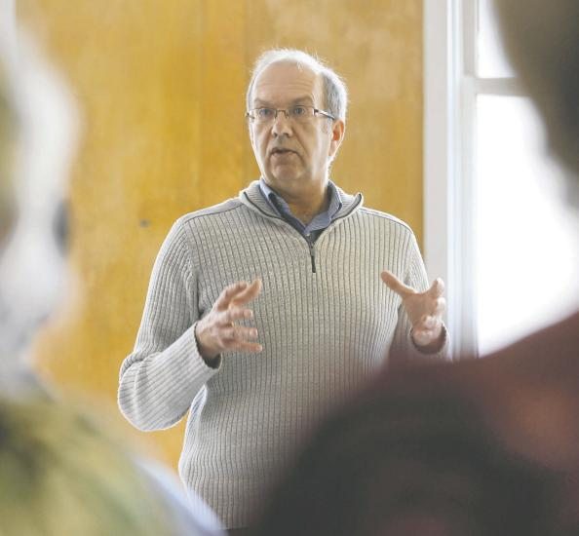PHOTO: BRUNSWICK NEWS ARCHIVERandy Hatfield, the executive director of the Human Development Council in Saint John, says the province needs to come up with an energy poverty reduction strategy to help the neediest struggling to pay high power bills.
Editor’s note: This is part three of our contribution to Postmedia’s 'How Canada Wins’ series, publishing across the country. In this installment, we look at a community organization that’s pushing to improve prosperity in New Brunswick – the Human Development Council.
Randy Hatfield was pleasantly surprised when the CEO of NB Power said she wanted to talk to him about rising electricity prices and the cost to low-income households.
The executive director of the Human Development Council in Saint John had advocated on behalf of the poor for years. But this was the first time the leader of the provincial Crown utility wanted to leave her towering headquarters in the capital to consult with a small nonprofit organization like his, more than an hour down the road in Saint John, in the heart of one of the city’s poorest neighbourhoods on Prince Edward Street.
“It was the first time any CEO of NB Power had reached out, and it was her initiation,” Hatfield said of that encounter in the fall of 2023, about six months after Clark had been appointed permanently to the top job.
“We met one morning with staff here in Saint John. She wanted to explain some of the challenges NB Power has and why rates are high in the province. After she left, it caused us to look deeper into energy, and to research and study the idea of energy poverty.”
The Human Development Council specializes in research, acting as a storehouse of information on poverty in the province, with a dashboard on its website providing the public with statistics on homelessness, social service needs, wages required to pay rents, and the like. It also has a pile of important reports – such as the real amount of a living wage in New Brunswick, $24.62 an hour, on average, in 2024, when by law, the minimum wage was just $15.30.
With NB Power preparing the groundwork for the biggest rate increases in generations, the council took the warning seriously, asking two researchers – Heather Atcheson and Liam Fisher – to do their own report on steep electricity prices.
The findings would spill into rate hearings last summer before the New Brunswick Energy and Utilities Board, which regulates electricity prices in the province and ultimately decided to give NB Power much of what it had asked for.
In April of last year, the board granted the utility a nearly 10 per cent hike, and this April will hike most rates by close to 10 per cent again, an increase that far exceeds inflation and income growth.
Even before the hikes, the researchers found that nearly 16 per cent of households in New Brunswick suffered energy poverty, that is, spending six per cent or more of after-tax income on electricity, a widely accepted standard.
It was the highest rate in the country.
Under cross-examination, NB Power officials were forced to expose the naked underbelly of what this meant for its poorest customers. In the 2022-23 fiscal year alone, even before the big rate increases, 44,694 NB Power customers were behind in paying their bills, more than one in 10.
And close to 3,600 households were disconnected for being too far behind in their payments.
These figures are expected to dramatically increase this April, when power rates are upped again.
Although the council did not convince the regulator to force NB Power to create an energy poverty reduction strategy – the independent board members demurred, stating it was up to the provincial government to create such programs – the nonprofit highlighted the consequences for the downtrodden.
And faced with a recent outcry from NB Power customers who have been shocked by the higher bills, Energy Minister René Legacy has hinted that help would be forthcoming for household ratepayers as early as April, without saying how.
Hatfield is pushing for an energy poverty reduction program like what’s offered in Ontario, many parts of the United States and Western Europe.
About half of New Brunswickers heat with electricity, rather than other sources like natural gas, pushing their power bills very high. Among the provinces, only Quebec and Newfoundland and Labrador, which have abundant and cheap hydro sources, have a higher rate of electric baseboard heat.
“They now have to recognize that energy poverty is real in New Brunswick,” the executive director said. “And it needs serious attention.”

